Ramyasri Singamsetty Partner: Yamini Dasu

EEE 117 Lab – Sergio Aguilar Rudametkin

5 September 2018

LAB 1 PRELAB:

MEASURING RESISTANCE, VOLTAGE, AND CURRENT MEASUREMENTS

**Part I. Resistance Measurements**

*Part 1 uses Figure 1*

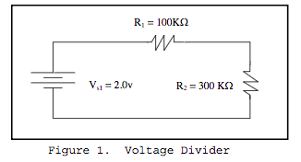

Table 1: Resistance, Channel 1 w/ X1 and X10 Probe, Oscilloscope On/Off

|  |  |  |  |  |  |
| --- | --- | --- | --- | --- | --- |
| Resistor | Resistance | Channel #1 of Oscilloscope w/ X1 probe | Channel #1 of Oscilloscope w/ X10 probe | Input Resistance: Oscilloscope On | Input Resistance: Oscilloscope Off |
| R1 |  |  |  |  |  |
| R2 |  |  |  |  |  |

Table 1: Specified vs. Measured Resistance Values

|  |  |  |
| --- | --- | --- |
| Resistor | Specified Resistance | Measured Values |
| R1 |  |  |
| R2 |  |  |

**Part II. Voltage Measurements**

1. Unloaded Voltage Readings

*Measurements of an input voltage and two resistor voltages.*

Vinput  = ____________ VR1  = ____________ VR2  = ____________

1. Loaded Voltage Readings (X1 Probe)

*Measurements of an input voltage and two resistor voltages with X1 probe added to Resistor 2.*

Vinput  = ____________ VR1  = ____________ VR2  = ____________

C. Loaded Voltage Reading (X10 Probe)

*Measurements of an input voltage and two resistor voltages with X1 probe added to Resistor 2.*

Vinput  = ____________ VR1  = ____________ VR2  = ____________

**Part III. Current Measurements**

*The resistor values are as measured in Part I.*

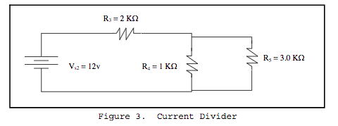

Current measurements of all 3 resistors in Figure 3.

IR3  = _____________ IR4  = _____________ IR5  = _____________

__________________________________________

Sergio Aguilar Rudametkin